

7th International Week, 13 - 17 May 2019
DRAFT PROGRAMME
Venue: Tito Square 4, Koper, Slovenia

Monday, 13 May 2019
9.30 – 10.00 | Registration
10.00 – 11.00 | Welcome and opening of the International Week 2019:  Presentation of the host university, city and country
11.00 – 11.30 | Presentation of participants
11.40 – 12.40 | First steps of the Slovenian language
12.40 – 14.00 | Welcome lunch
14.00 – 16.00 | Guided tour of Koper

Tuesday, 14 May 2019
13.00 – 14.30 | Lecture “Internationalizing Slovenia: Feel the Green, Active and Healthy Destination”
Free-time
16.00 – 18.00 | Presentations of participants’ home universities’ and their best practices
18.00 – 20.00 | Dinner “Getting to know each other”

Wednesday, 15 May 2019
9.30 – 16.00 | Boat Excursion Koper – Piran – Koper

Thursday, 16 May 2019
9.30 – 10.30 | Workshop “Hidden competences”
10.40 – 11.20 | Visit of the Koper City Hall
Free-time
13.00 – 14.00 | Meeting with representatives of UP departments and faculties

Friday, 17 May 2019
9.30 – 10.15 | Presentation of Confucius Classroom Koper
10.15 – 11.15 | Closing of the International Week 2019
 | (Group and individual discussion, Evaluation, Certificates of attendance award)

The programme activities are planned for administrative staff.
Teaching staff is welcome to offer guest lectures during the International Week which have to be agreed with the host faculty*. Teaching staff may also participate in the programme activities.

Participation fee is 20,00 €.
Participants are responsible for their own travel arrangements and hotel accommodation.

Application:
 |  | To apply for the “International Week 2019 of the University of Primorska” please fill in the on-line application form available at: https://vis.upr.si/studij/empexchange/tujcizap_prva.asp  by 2 April 2019 at the latest.  The selection of candidates will be done by 5 April 2019.
Further information: | Ms. Maja Bratuš Vidmar  Department for Education, International Cooperation and Quality Assurance  E-mail: maja.vidmar@upr.si  Tel.: ++386 5 61 17 634
* Contacts at the faculties of the University of Primorska:
1) Faculty of Humanities: Ms. Valentina Bertok (valentina.bertok@fhs.upr.si)
2) Faculty of Management: Ms. Marisol Pribac (marisol.pribac@fm-kp.si)
3) Faculty of Education: Ms. Tina Kadunec (tina.kadunec@pef.upr.si)
4) Faculty of Tourism Studies - Turistica: Ms. Nataša Gržinić (natasa.grzinic@fts.upr.si)
5) Faculty of Mathematics, Natural Sciences and Information Technologies:
Mr. Aleš Oven (ales.oven@famnit.upr.si)
6) Faculty of Health Sciences: Ms. Andreja Brecelj (andreja.brecelj@fvz.upr.si)

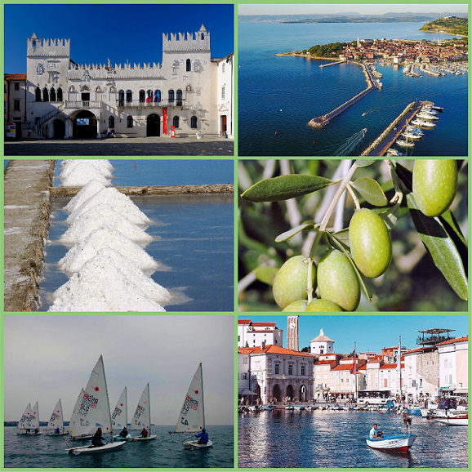

COME AND JOIN US!

